Assuming you have followed the setup instructions on elms (in an announcement by Levi), here below is what we can do to test this out.

First is to setup the alexa skill.

At Build page, we need to first give it a name.

We can set the name to “team two robot”. And later on when we want to invoke it, we will say “run team two robot”.

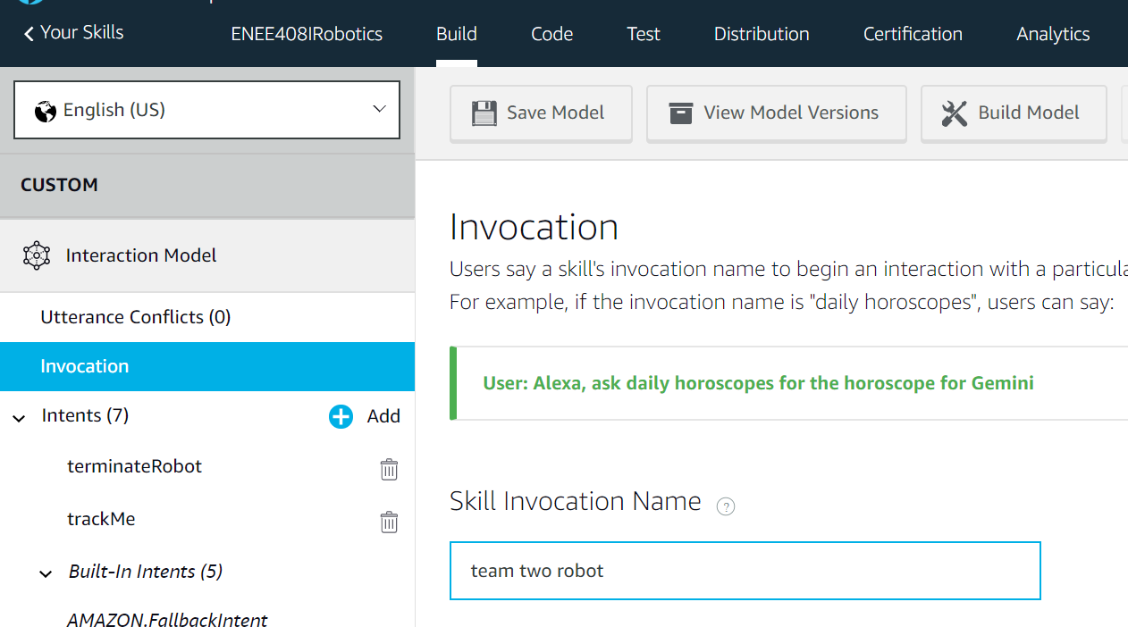

Then, we want to ask the robot to execute some instructions. To do this, we need to create some intents.

The name of the intent has to agree with what our code has.

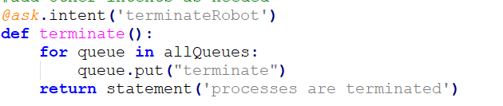

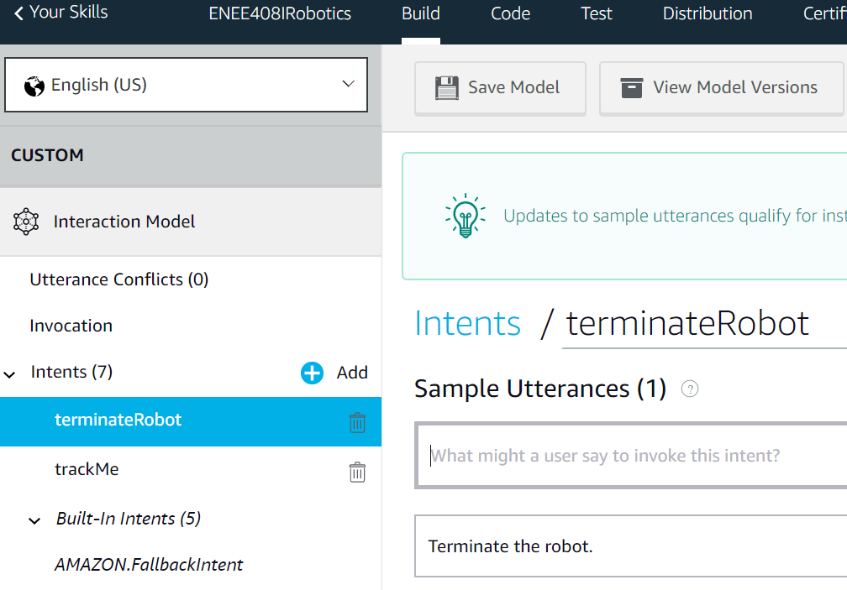

First is what we should say to make the server send the intent to our local machine. In this case, we will say:

1. If the skill has been invoked (that is, we have said “run team two robot” right before we want to send intents):

“Terminate the robot.”

1. If the skill was not invoked:

“Alexa, ask ‘team two robot’ to ‘terminate the robot’.”

Note, the invocation status of the skill will be reset once we have sent an intent.

We can also include an intent confirmation so on receiving the intent, alexa will ask for confirmation which we will reply with ‘yes’ or ‘no’.

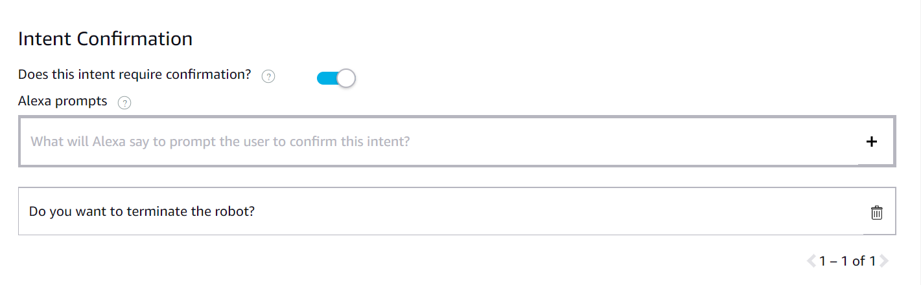

After setting up all of the intents, we can build our model.

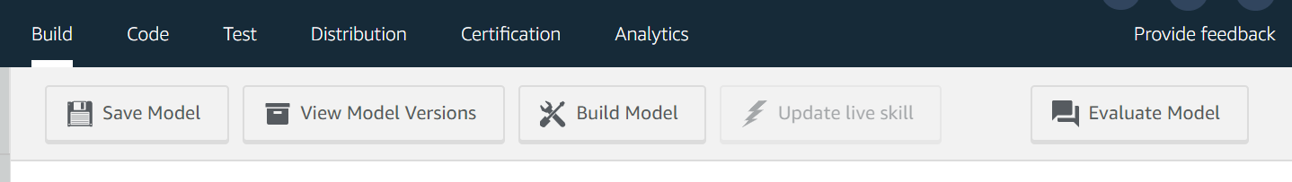

And the very last thing is to set the endpoint for our connection. This is carried out by using ngrok.

Note, the ngrok must be running during the whole time when the robot is running. Thus, we need to open a dedicated window for it.

Place the ngrok executable in the root folder of the project. To run ngrok go to the project folder and type:

./ngrok http 5000

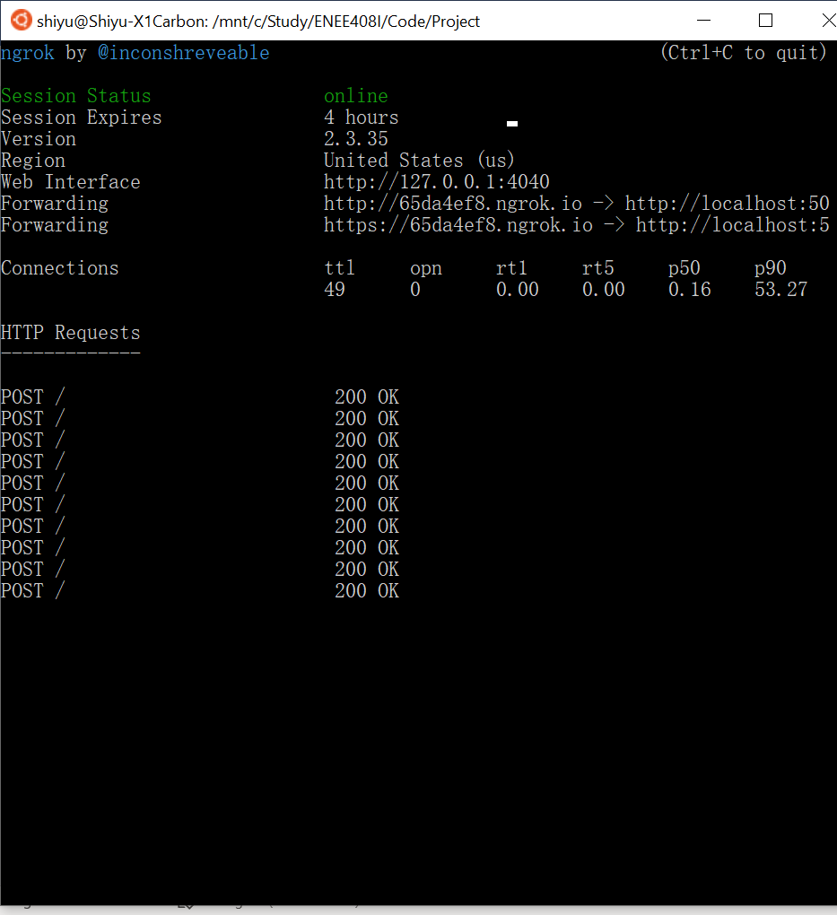

When you see this, copy the https address to the skill end point and save. We have to set end point on alexa skill manually every time when we want to setup the connection. (We do not have to rebuild every time though, saving it will do the work)

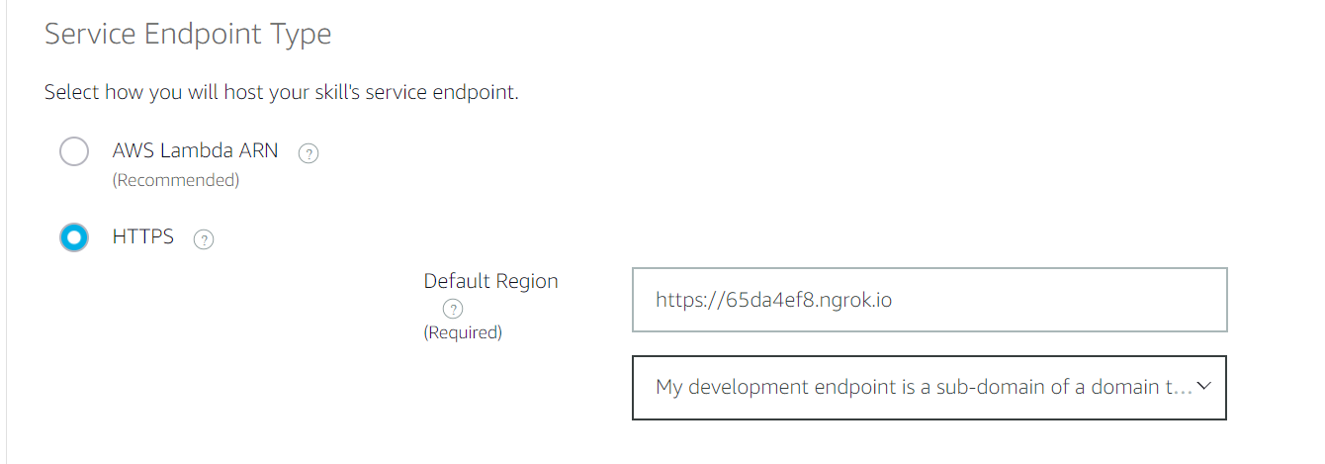

Then to test the skill, we can go to the test page. We do not have to use echo or phone necessarily. We can simply type in the text box. However, if you want to do it with echo/phone, just simply setup the echo using the same email address as the one you registered the alexa skill with.

Below is my test result:

